Volume 4, Issue 11 December 2005
Employment Brief
Prepared by Christine Su, Ph.D.

Disability Mentoring Day Hawai`i - 2005

This brief is one of a series of briefs from the National Technical Assistance Center for Asian Americans and Pacific Islanders with Disabilities (NTAC-AAPI), designed to provide information on strategies for securing employment for people with disabilities. These briefs discuss the value of mentoring as a means for individuals with disabilities to explore various career options, including mentoring as an avenue for employers to learn about disability culture, to clarify misconceptions about hiring workers with disabilities, and to contribute to their communities by becoming mentors. The current issue discusses Disability Mentoring Day participation in Hawai`i in October, 2005.

Introduction

The National Technical Assistance Center for Asian Americans and Pacific Islanders with Disabilities (NTAC-AAPI), based at the University of Hawai`i at Manoa’s Center on Disability Studies, was proud to commemorate “Disability Mentoring Day: Career Development for the 21st Century,” on Wednesday, October 19, 2005.

Disability Mentoring Day (DMD), first organized by the American Association of People with Disabilities (AAPD) and the U.S. Department of Labor in 1999, is a widespread effort to promote the employment of persons with disabilities through personal mentoring. In Hawai`i, DMD is coordinated through NTAC-AAPI, with the support of local businesses and agencies. NTAC-AAPI gratefully acknowledges the enthusiastic participation of public and private employers in DMD Hawai`i-2005. Twenty-five individuals participated on O`ahu in 2005, an increase of nearly 50 percent over the number of participants from 2004. In addition, this year’s DMD was also held on the Big Island of Hawai`i, with the support of Puna Kamali`i Flowers.

During Disability Mentoring Day, job-seekers and students with disabilities as meentees are paired with representatives of locally-based businesses or agencies in career fields that match their interests. A primary goal of DMD is to provide people with disabilities insight and hands-on experience in various professions that appeal to them, rather than arbitrarily placing mentees in just any job. AAPD materials assert that it is important for people with disabilities to have the opportunity to explore:

not just entry-level and dead-end jobs, but careers. Mentoring takes more than one day. But DMD can get the process started and draw national attention to the importance of encouraging young people with disabilities to develop the skills and obtain the experiences necessary to compete in today’s economy (see http://www.dmd-aapd.org/).

Despite passage of the Americans with Disabilities Act (1990) and subsequent policies, many individuals with disabilities of working age remain unemployed. Across the country, many employers are still uncomfortable hiring people with disabilities, largely because of misconceptions about the effects hiring people with disabilities will have on their companies. Some employers believe the type or nature of the work in their companies cannot be effectively performed by workers with disabilities. Others fear they might face litigation under the Americans with Disabilities Act (ADA) for mistakes in compliance with ADA requirements. Many worry that the cost of accommodating workers with disabilities would be too high (Dixon, Kruse, and Van Horn, 2003). Thus Disability Mentoring Day can be a point of entry for employers to learn more about individuals with disabilities to dispel such fears. People with disabilities are an untapped source of possible interns and future employees.

DMD in Hawai`i

This year’s participation in DMD-Hawai`i demonstrates the diversity of both mentees and mentors involved in the effort. NTAC-AAPI mentees represented job-seekers of all working ages, both male and female, with a variety of career interests, ranging from computer science to criminal justice to alternative medicine. Accordingly, mentors represented a multitude of related professions, from programmer to investigator to holistic health practitioner. A sampling of matches appears in the table below.

Mentee career interest: | Paired with mentor in:
Criminal justice | Office of the State Attorney General, Investigations Unit
Human resources | Human Resources department at a large hotel resort
Higher education | Local business college, Career and Student Services Dept.
Alternative medicine | Local Dahn Hak Wellness Center
Law | US Citizenship and Immigration Services Center
Small business and the arts | Local non-profit organization specializing in art and self-employment

Most mentors welcomed their mentees on October 19th, the national mentoring day. Others mentored on October 20th or other surrounding dates, if they were unable to participate on the 19th itself, yet did not want to miss the opportunity to be mentors. NTAC-AAPI would like to thank the following companies for their outreach to individuals with disabilities, and for their demonstration of leadership in the Hawai`i community: the Center on Disability Studies, the University of Hawaii at Manoa; the Dahn Hak Wellness Center; Hawaii Artsplace; Hawaii Business College; Hawaii Public Radio; Hawaii Services on Deafness; Hilton Hawaiian Village Resort and Spa; National Institute on Mental Health; Dr. Randall Nitta, M.D.; Office of the Attorney General, State of Hawaii, Investigations Unit; and the United States Citizenship and Immigration Services.
Some employers planned for the students/job seekers to come directly to their work site, with different activities scheduled throughout the day. Mentees were able to attend meetings and programs, while also having time dedicated to one-on-one job-shadowing and conversations between the mentor and mentee. Most employers gave mentees a tour of the work site, which often involved meeting different personnel and learning about the components of the organization. Each mentee had an opportunity to see what a day “on the job” is like.

Mentee Mohammad spends time with mentor Jasmine at the University of Hawaii Center on Disability Studies
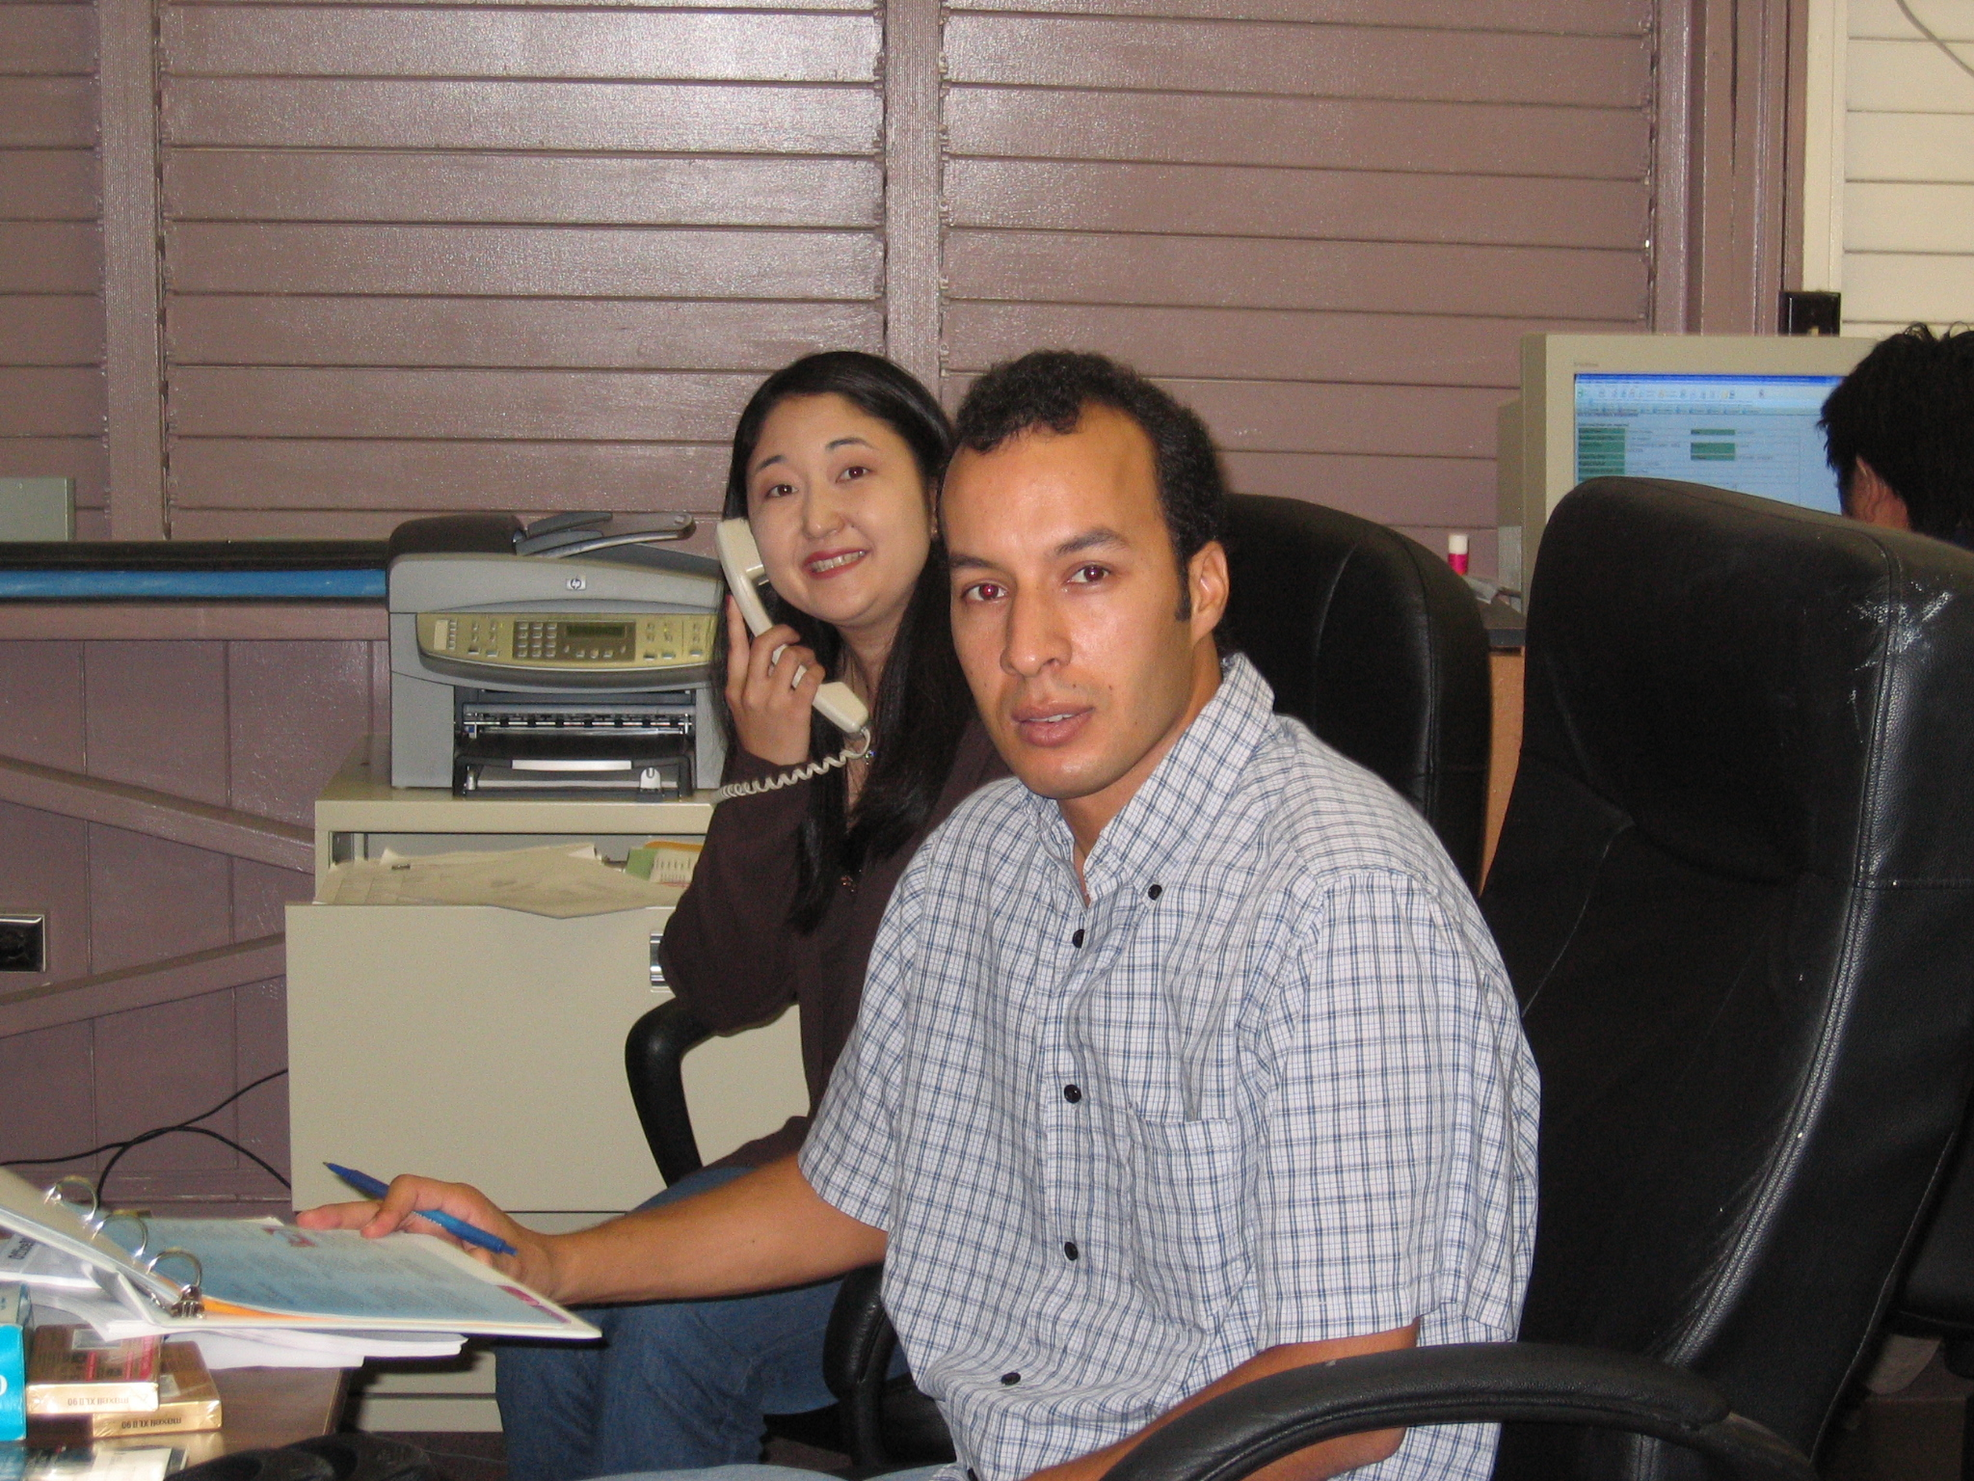
Photo by Christine Su

As well as breaking down employer fears, mentoring increased mentees’ confidence in securing gainful employment. At a celebratory dinner for the mentees on Friday, October 21st, participants shared their experiences with various Hawai`i employers.

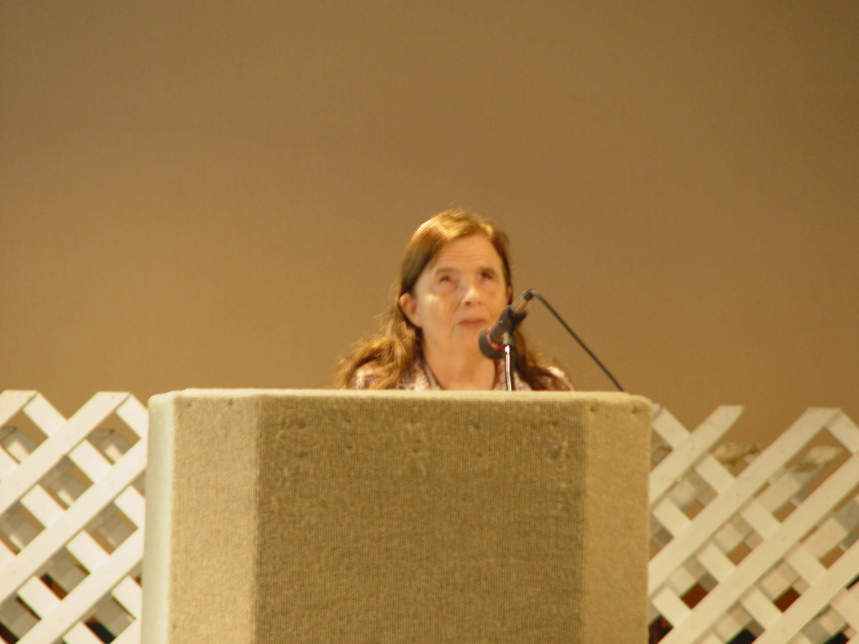Photo by David Baker.

Mentee Maureen shares her DMD experiences at the closing dinner.

“I had a wonderful experience,” said Maureen Sheedy, a first-time mentee who shadowed someone in a non-profit organization. “And it was so refreshing to work with someone who was open to finding creative ways for me to do jobs others would ordinarily think I couldn’t do! Now I’m planning to volunteer there—the experience made such an impact on me.”

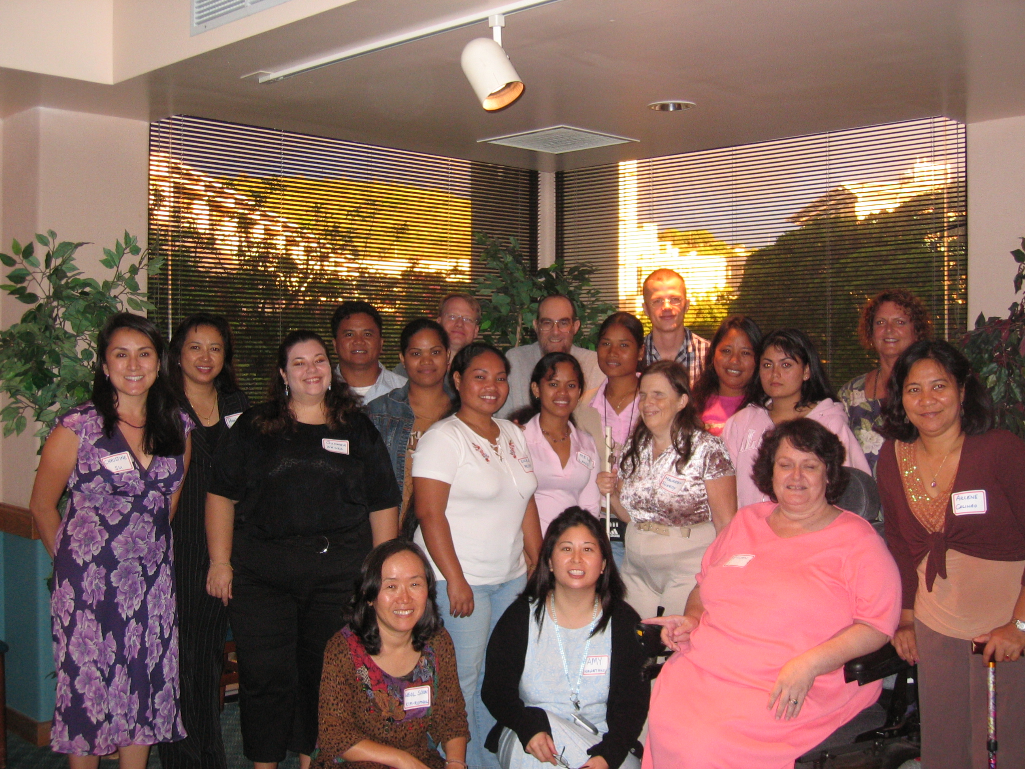
Photo by David Baker
Mentees and mentors gathered at a closing dinner for
Disability Mentoring Day Hawai`i - 2005

Get Involved

There are more than 140,000 individuals with a disability in the State of Hawai`i. Of these, approximately fifty percent are aged 16 to 64--of working age.

If you are a Hawai`i employer interested in participating as a mentor for Disability Mentoring Day 2006, or are willing to serve as a mentor at another time during the year, please contact the National Technical Assistance Center for Asian Americans and Pacific Islanders with Disabilities (808) 956-2890, or at ntac@hawaii.edu.

If you are a Hawai`i job-seeker interested in participating as a mentee for Disability Mentoring Day 2006, or as part of our year-round mentoring program, please contact James Brightman, (808) 956-4585, or james.brightman@cds.hawaii.edu.

References

Dixon, K.A., Kruse, Doug, and Van Horn, C. E. (2003). Restricted access: A survey of employers about people with disabilities and lowering barriers to work. John J. Heldrich Center for Workforce Development, New Brunswick, New Jersey. Retrieved November 10, 2004, from www.heldrich.rutgers.edu

U.S. Census Bureau. Hawaii—Selected Social Characteristics: 2004. Retrieved November 29, 2005, from http://www3.hawaii.gov/DBEDT/images/User_FilesImages/census/Files/American_Community_Survey/2004/04state_tab2_a2020.pdf

For more information on Disability Mentoring Day, visit www.dmd-aapd.org.

The information in this brief can be provided in accessible formats upon request.
NTAC-AAPI Information Brief Series, http://www.ntac.hawaii.edu/
Center on Disability Studies • 1776 University Avenue, UA4-6 • Honolulu, HI 96822

